Micom Writting Controller Board

1. Block diagram



1. Schematic

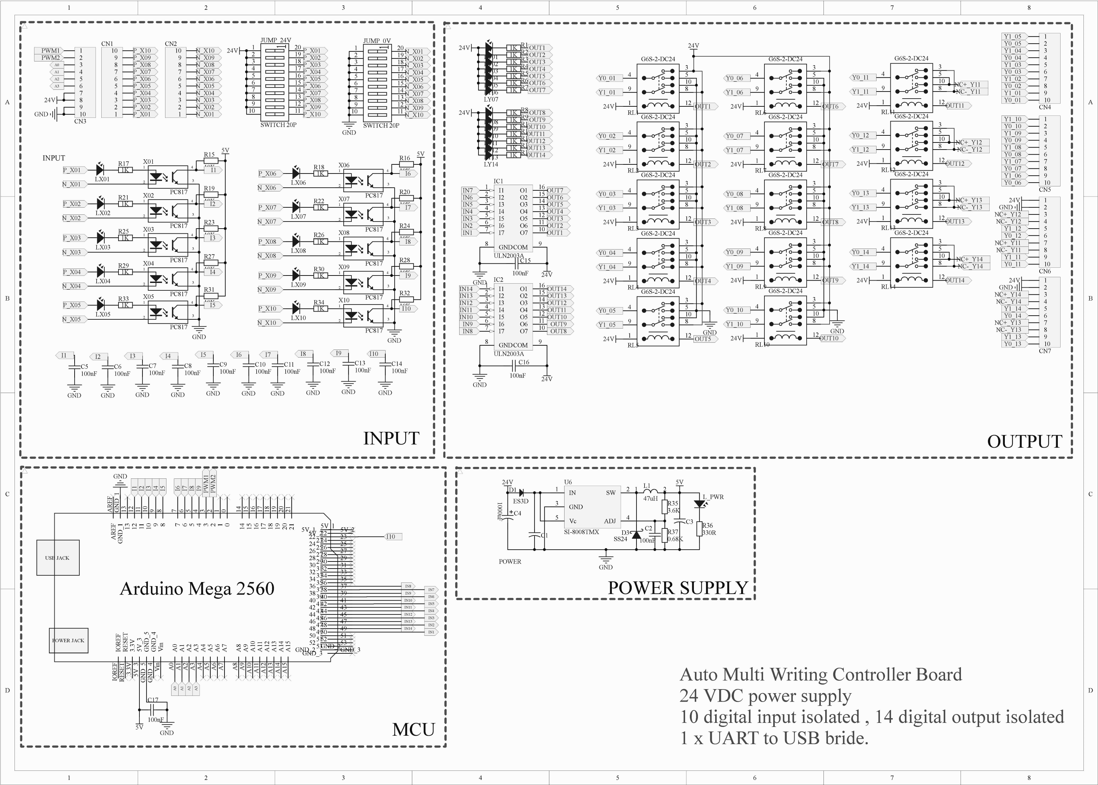

1. PCB

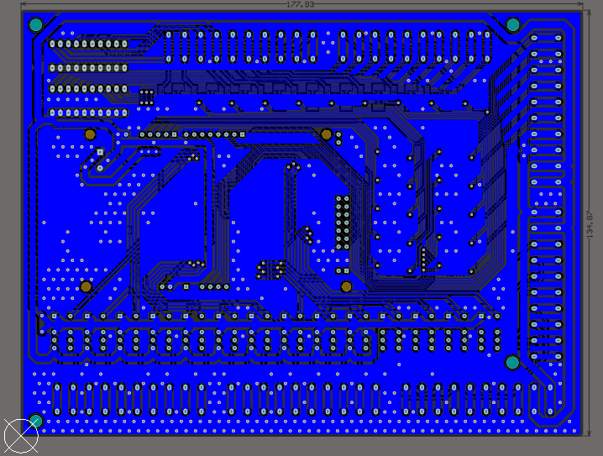

Bottom

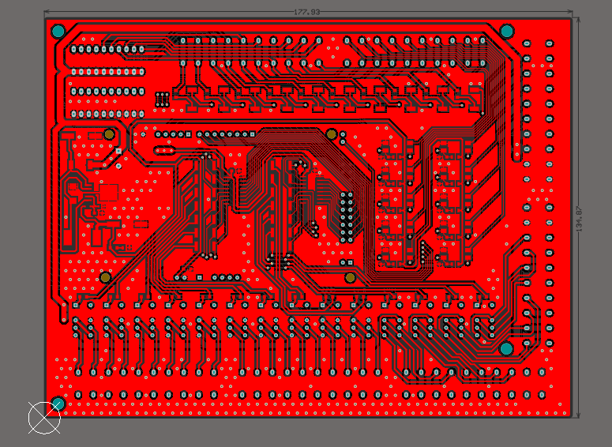

Top

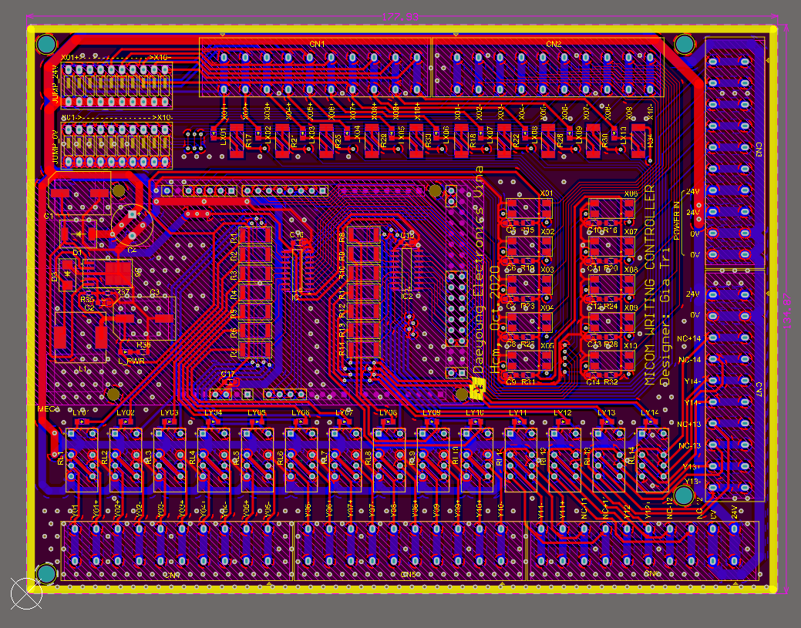

Full layer

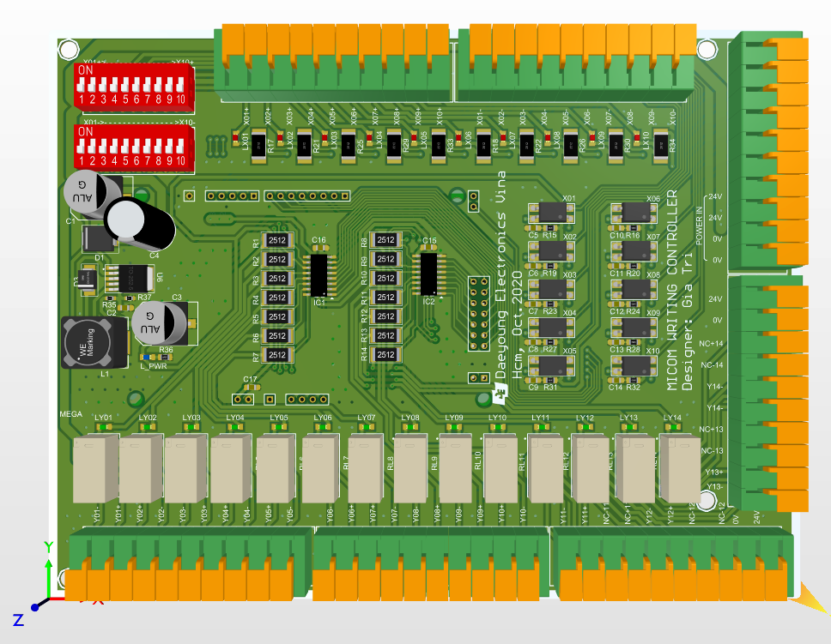

PCB 3D

1. Specifications

* Electrical
  + Power supply:
    - 24VDC
    - Current min 1A.
  + 10 input:
    - 0 – 24 VDC
    - 0 – 500 mA
    - Opto Isolated
    - Active Low
  + 14 output
    - Max voltage: 30VDC
    - Max current: 2A
    - Max operate/reset time 4ms
    - Opto isolated
    - Had NC/NO connector
* Physical
  + Dimensions (width x height ) : 178 x 135 (mm)
  + 4 x Ø4(mm) fixed hole